QSAN Configuration - (Ormet Qsan01)

# SYSTEM CONFIGURATION

Systemname : SAN_vCnet01

Network setting : MAC address : 00:13:78:B7:08:40

Static 10.10.11.1

Mask 255.255.0.0

Gateway 10.10.5.101

DNS 8.8.8.8

Http port : 80

Https port: 443

SSH port : 22

Login setting

Auto logout : disable

Login lock : disable

Mail setting from : [support@consul-net.it](mailto:support@consul-net.it)

to [support@consul-net.it](mailto:support@consul-net.it)

evnet : info yes warning yes error yes

Smtp : smtp server : posta.consul-net.it:25

authentication : login

account [support@consul-net.it](mailto:support@consul-net.it)

password supcon15

Notification setting snmp : (none)

Active directory setting : (none)

User setting admin admin local

user user local

# iSCSI configuration

NIC - Controller 1

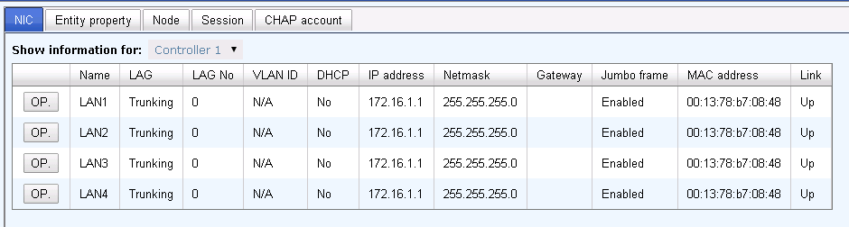

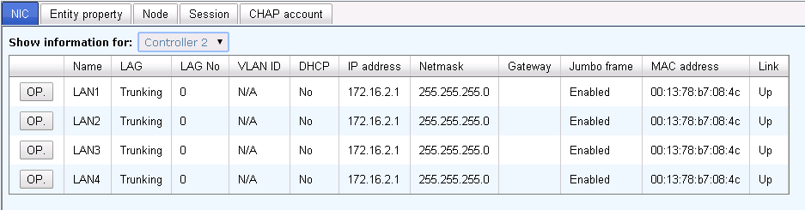

Entity property

entity name : iqn.2004-08.tw.com.qsan:p300q-d316-fff906ad8

iSNS IP : (none)

CHAP account : no user now !

# 

# Volume configuration